


SUCCESS PLANNER 2020

Planning is essential to achieving a successful business.

Your vision for success
Using the prompts below write or review your existing business mission, vision and values for 2020. Put these in a prominent place so you can refer to these over the coming year.

Bonus tip
If you are really inspired, get creative and turn your vision into a vision board – easy to do with magazines, paper and a glue stick.

Mission:
A mission statement is your big picture, it describes the overall purpose of your business and is usually a couple of sentences long. This is a helpful article on crafting your mission statement: https://www.entrepreneur.com/article/240085

Vision:
A vision sets the direction for your business. This is important for you and for your clients as well. Your vision will energise and inspire you, it gets the attention of potential clients and builds trust, respect and loyalty. This is a helpful article on crafting your vision statement, and highlights well the comparison with your mission: https://www.entrepreneur.com/article/245249

Values:
Values represent the core priorities of your business and how it operates. Choose four to six of these, or create your own, and in a few words describe why they are important to you.
If you are interested in an online values assessment, this one is quite good: https://survey.valuescentre.com/survey.html?id=s1TAEQUStmx-pUIle-ma6Q

Affordability
Acceptance
Assistance
Balance
Challenge
Confidentiality
Creativity
Confidentiality
Dedication
Development
Devotion
Discovery
Effectiveness
Encouragement
Energy
Excellence
Exclusivity
Experience
Fairness
Family
Flexibility
Growth
Honesty
Inspiration
Improvement
Learning
Knowledge
Observation
Originality
Partnership
Passion
Positivism
Quest
Reliability
Respect
Results
Safety
Sensitivity
Stimulation
Strengths
Support
Sustainability
Triumph
Trust

Your goals
You now have a place to come from in creating your goals for the year. Consider these five areas, and write down SMART (Specific, Measurable, Achievable, Time-framed) Goals:
- Revenue generating goals
- Content goals
- Marketing goals
- Communication goals
- Personal goals

I use this format:

Goal | What I need to do (action) | Obstacles I may encounter | How I will overcome these | Date completed

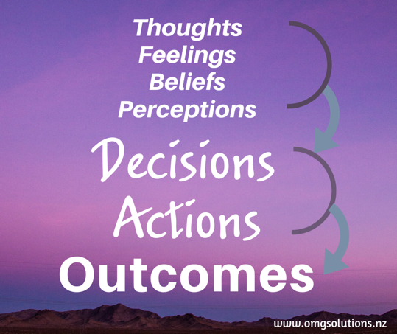
Daily success
Every day we make decisions (take actions) based on what we think, believe, perceive, and feel. By becoming aware of what is impacting our decisions (taking off our glasses) we can make more informed choices in business and produce success outcomes.

There are many tools and techniques for creating a successful day, things you can commit to that will help you on your way to achieving your goals. Each day I start with a brain dump (everything in my head about the day, good/bad and otherwise), then I use the below planning sheet. (You could adapt for your needs).

DAILY PLANNING
Daily affirmation or business goal

Must do today | Other to do’s
1.
2.
3.
Clients to reach
1.
2.
3.
Meetings | Weekly money goals
1. | $
2. | Money flowing in
3. | $
Awesome ideas
Invoices/payments | Other
All the best for a successful 2020!

